**This document details a proposed tracking system for all future REDCap projects. Individuals will first interface with a REDCap webpage that briefly summarizes the training support options currently available. If an investigator is interested in pursuing any of the options, they then click on the REDCap logo to initiate a project request. Project request information is then entered into a REDCap survey form (see Project Request Form below). Once submitted, this information can be viewed by the support team staff (the BBMC) using the access-controlled GUI (see Project Request Data Form). After viewing this information, it will be the responsibility of the support team to triage the project to the appropriate personnel for scheduling an initial REDCap planning meeting (with the research team) and obtaining signed copies of the TBD REDCap Use Agreement (see other attachments provided). These initial planning meetings will further probe for project specifics and will transfer this information to the Research Document Form within a separate (but linked to the REDCap Survey project), access-controlled (support-team only), tracking project. After a development plan is established during the initial meeting(s), progression of project-specific developments will be chronicled in the other forms of the access-controlled, tracking project (REDCap Project Initial Development, Project Information, Consults, Project Review, and Project Review Checklist, and Metrics forms).**

**Example of a REDCap Webpage**

On the initial web interface, there will be a link to request access to REDCap for project creation and consultation.

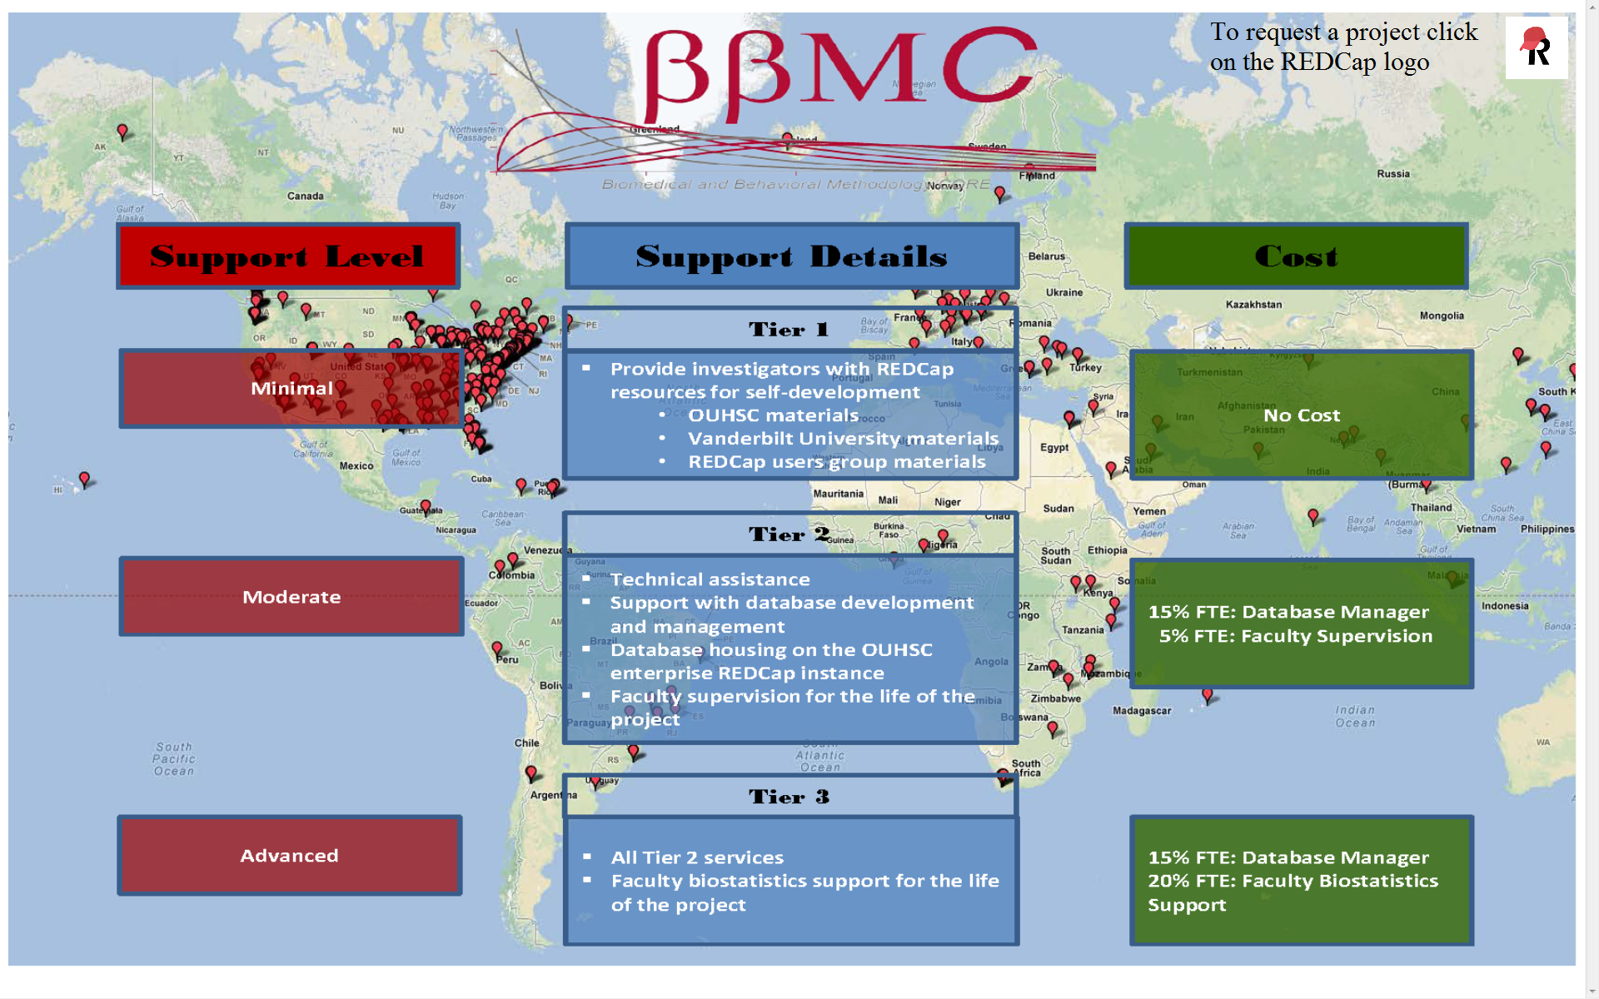

**Project Request Survey Form**

The link will take you to a REDCap survey that the interested party fills out. Once submitted, the data are stored in a REDCap project.

Top of Project Request Survey Bottom of Project Request Survey

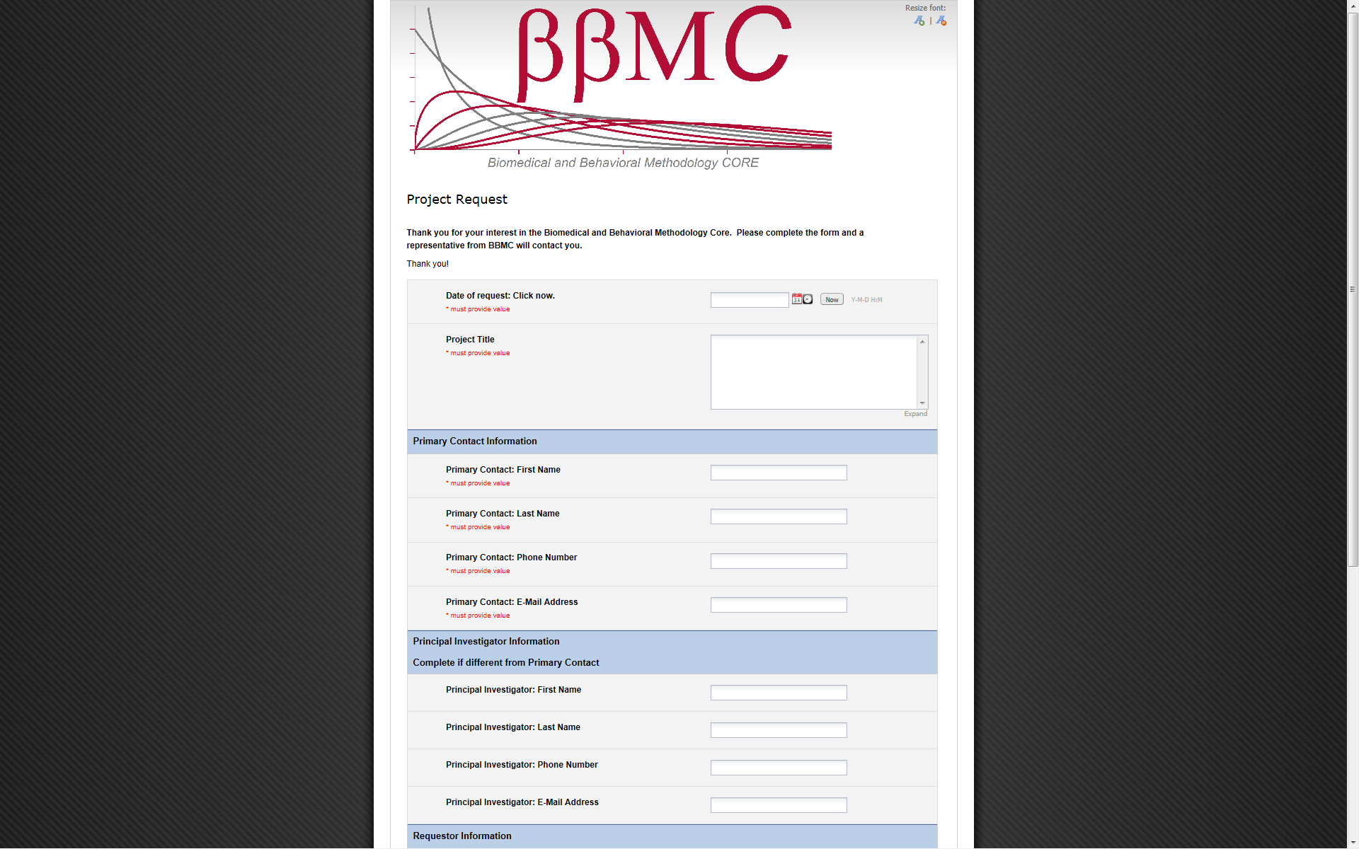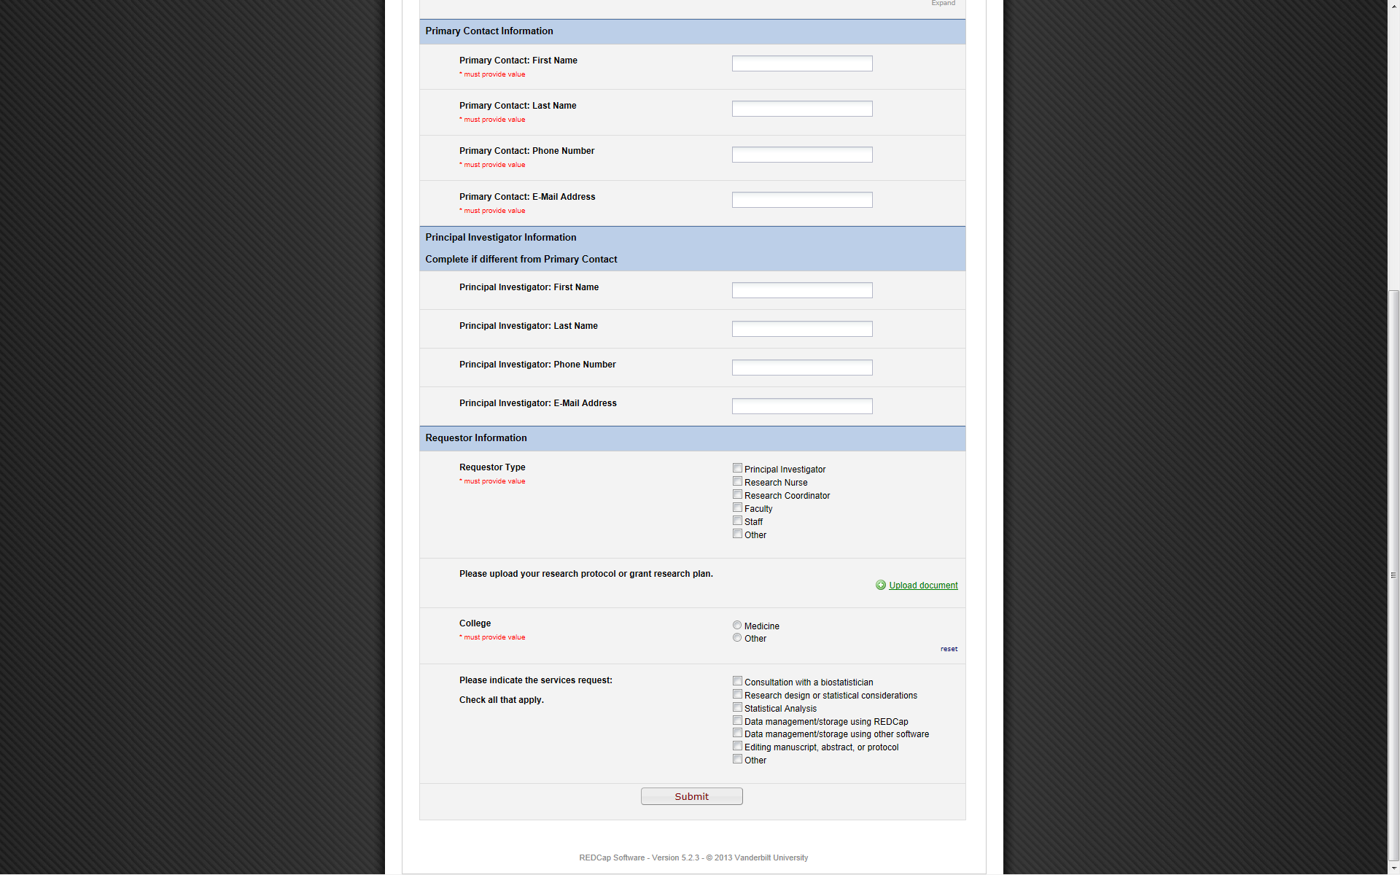

**Project request data form**

This is a restricted-access, middle layer that exists between the back-end database and the Project Request survey. All data collected using the survey can be viewed here. If needed, those with appropriate user rights (i.e., support team personnel) can edit data from the survey on this form.

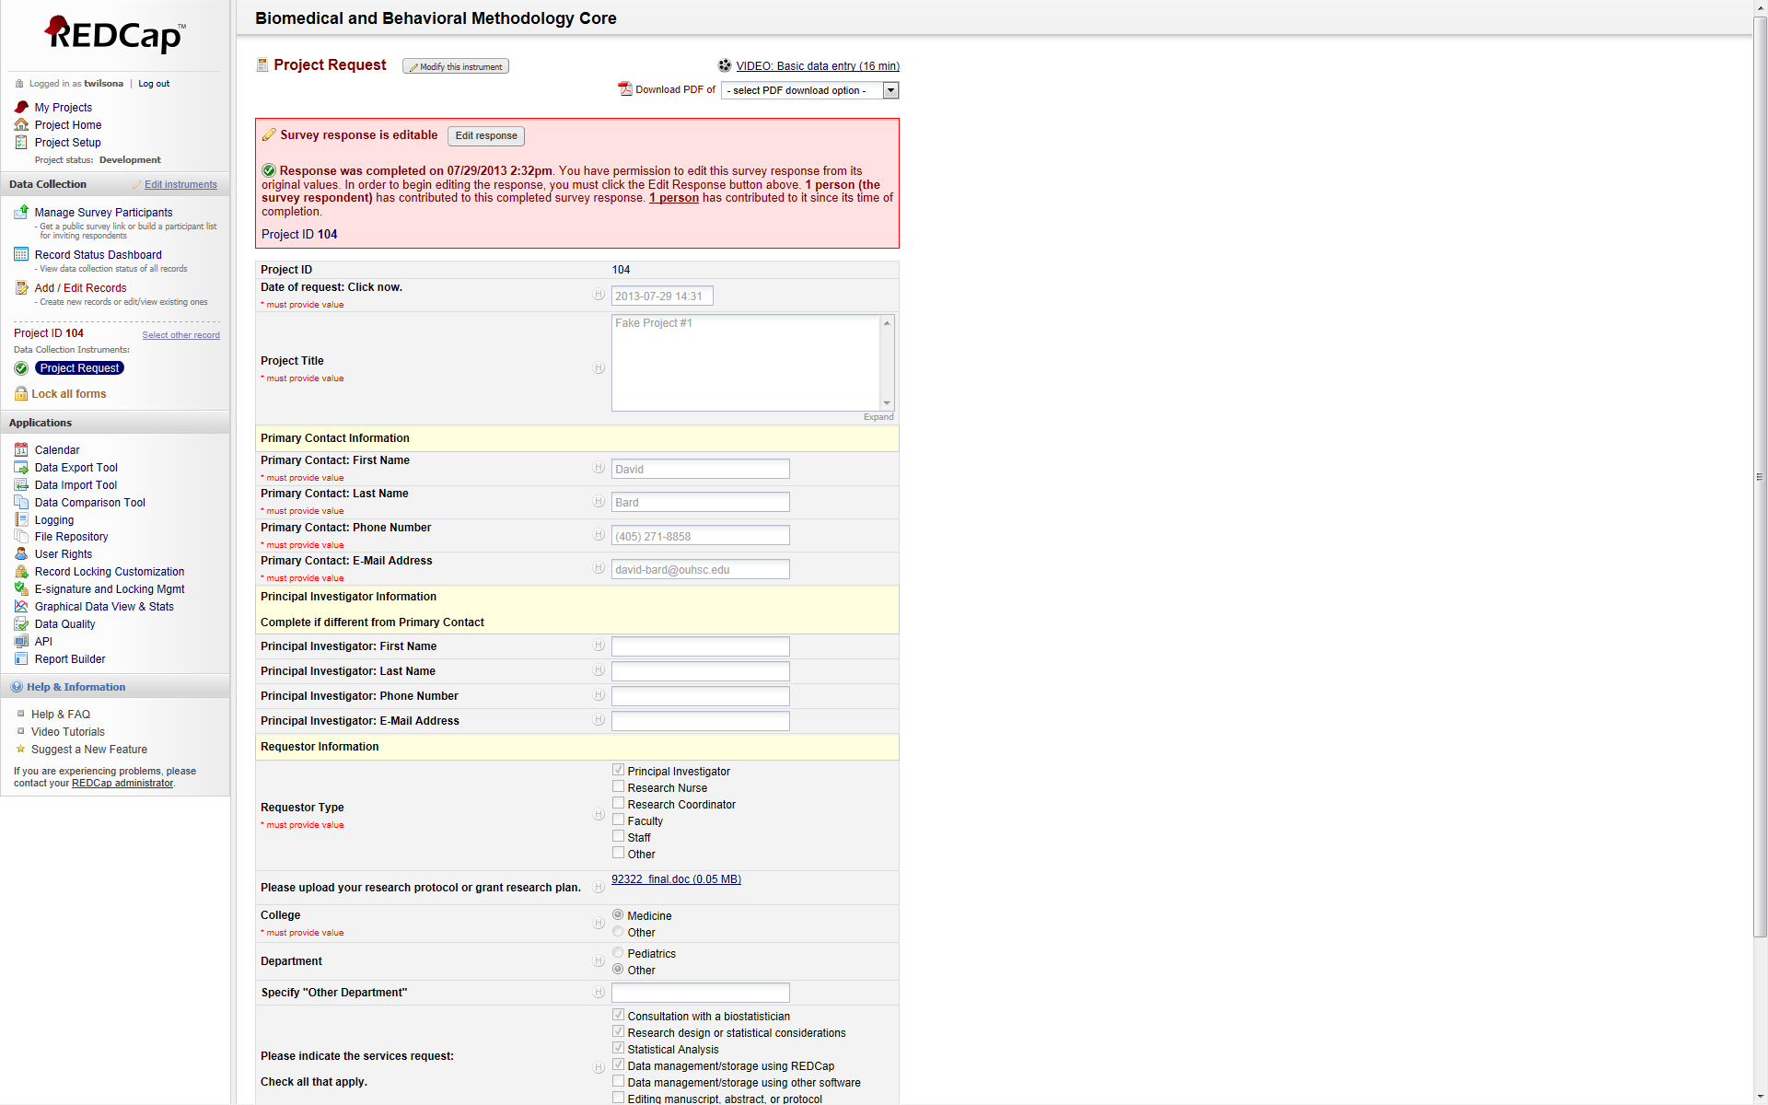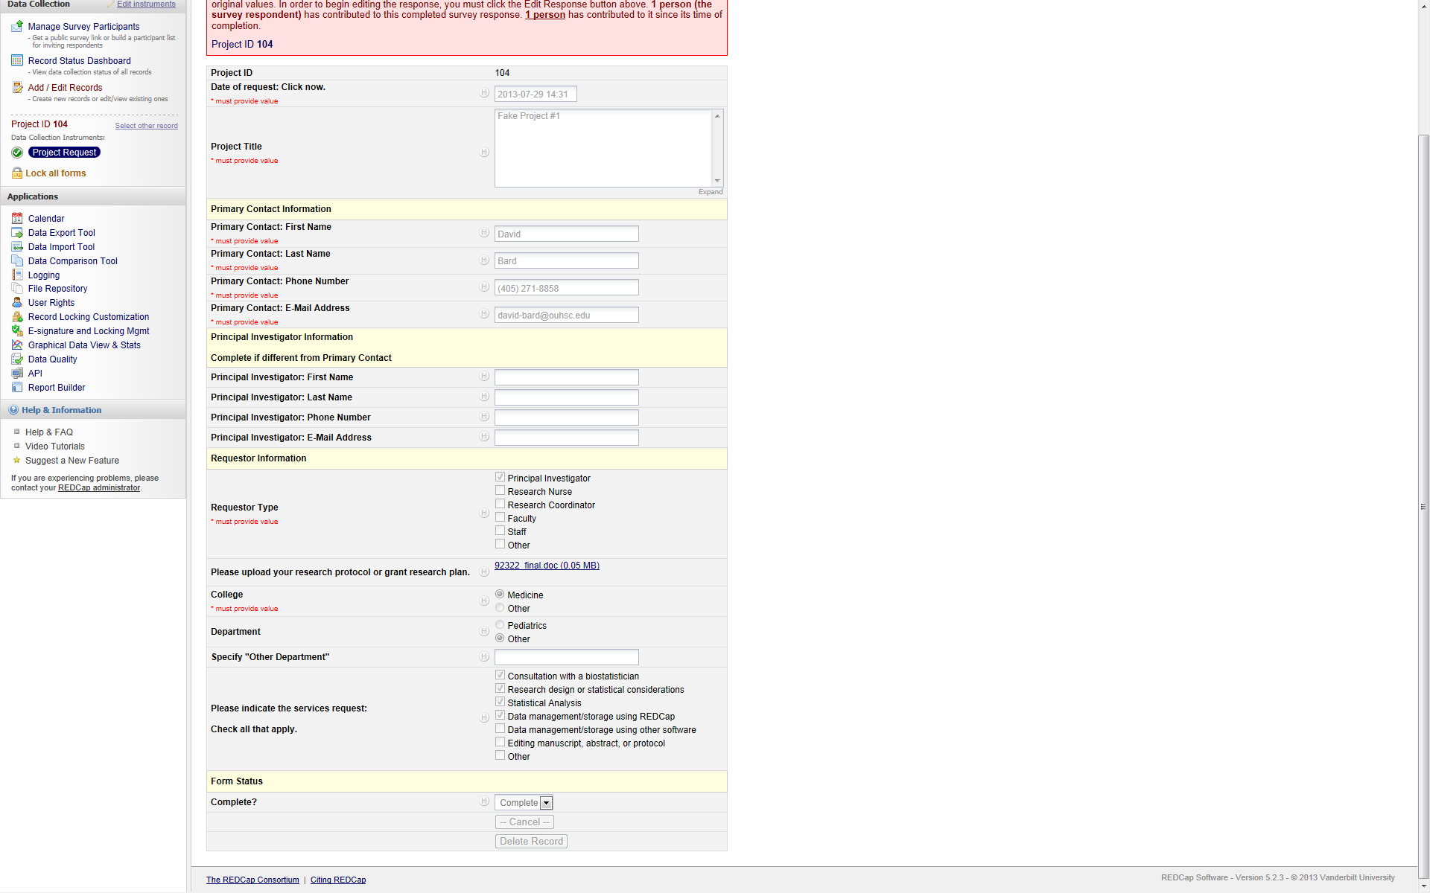

**Research Document form**

The research document form is used to collect and store copies of relevant project documents. Looking at the screen shot, you can see that the documents “Other 1” and “Production Data Dictionary” are the only fields that have had a document uploaded.

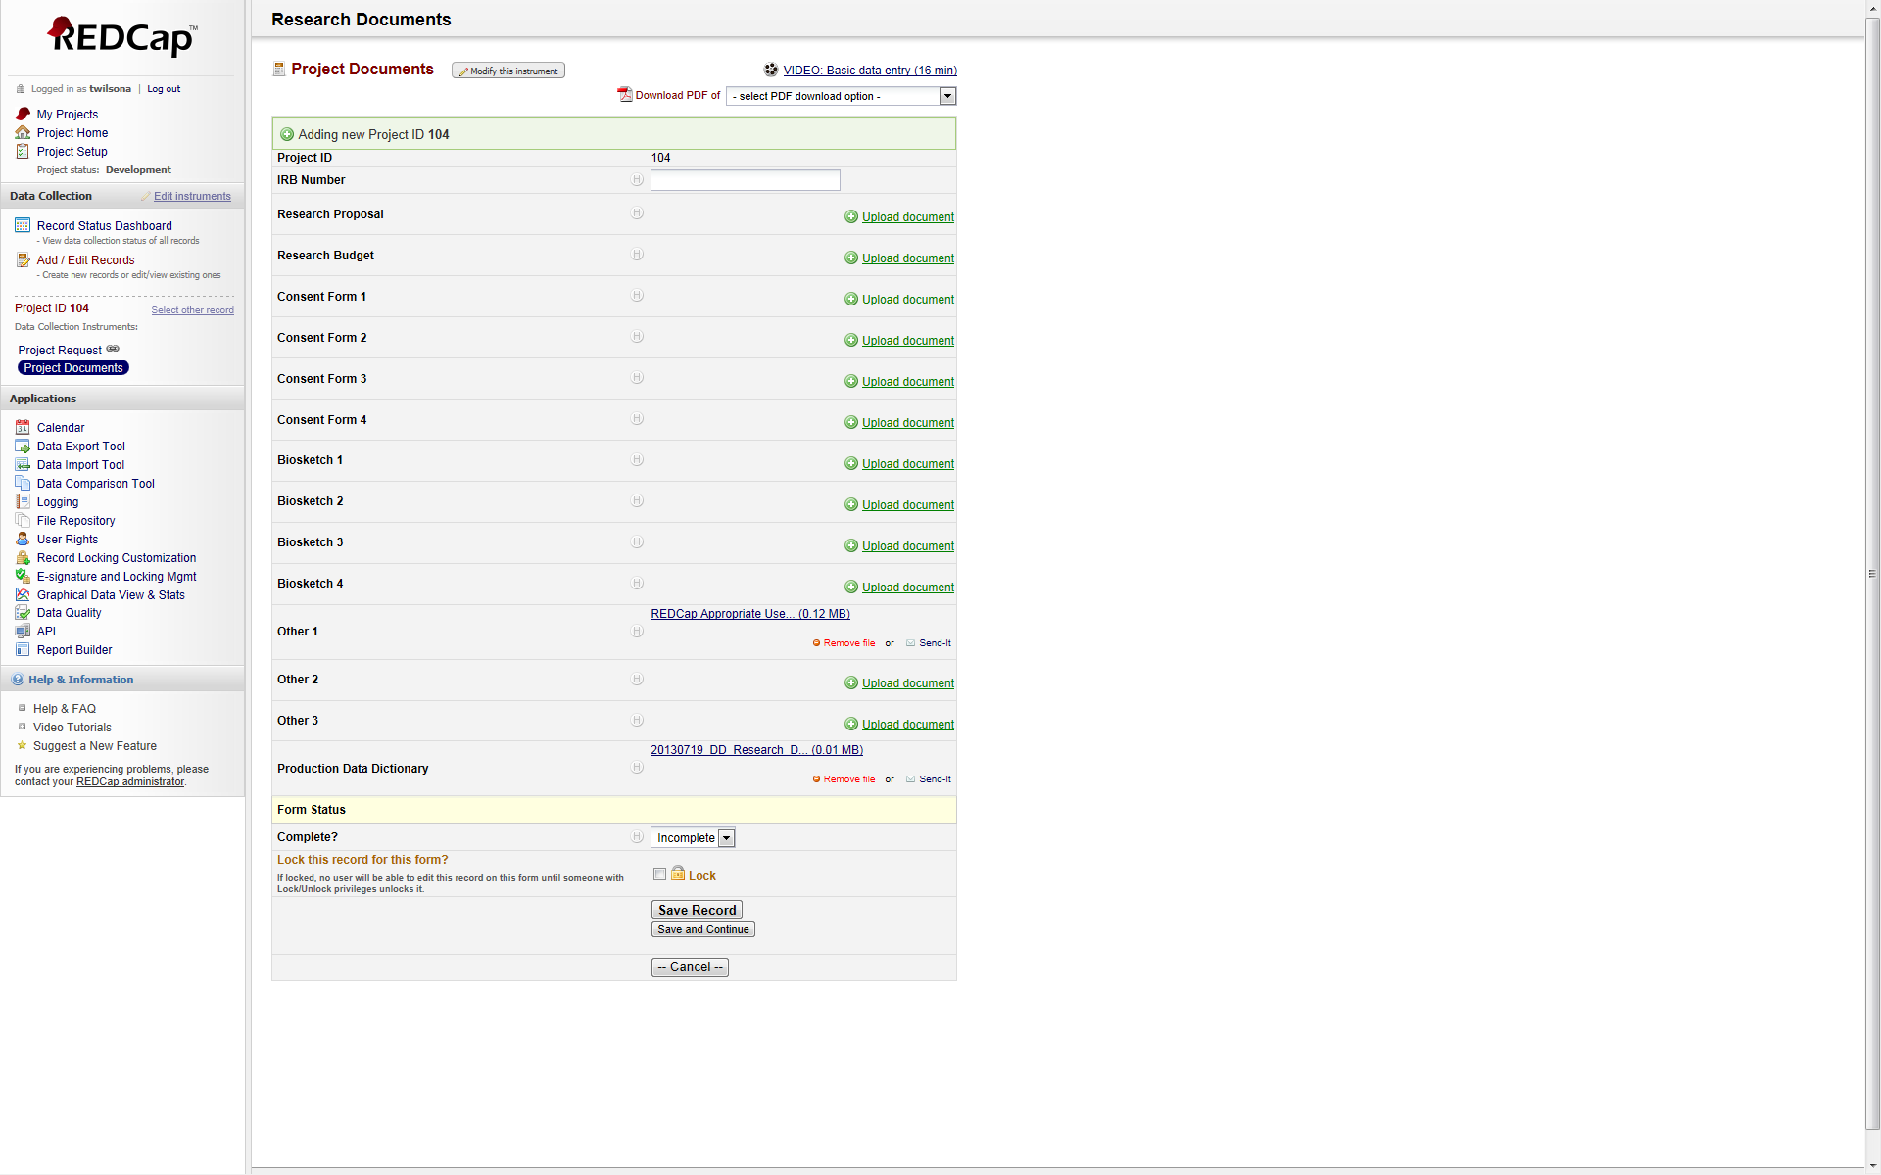

**REDCap Project Initial Development**

This is the main menu for the initial development of a project after an official REDCap project request. This project is used to store data related to the development of a client’s REDCap database. This is also used to calculate metrics related to the cost and time involved in project development.

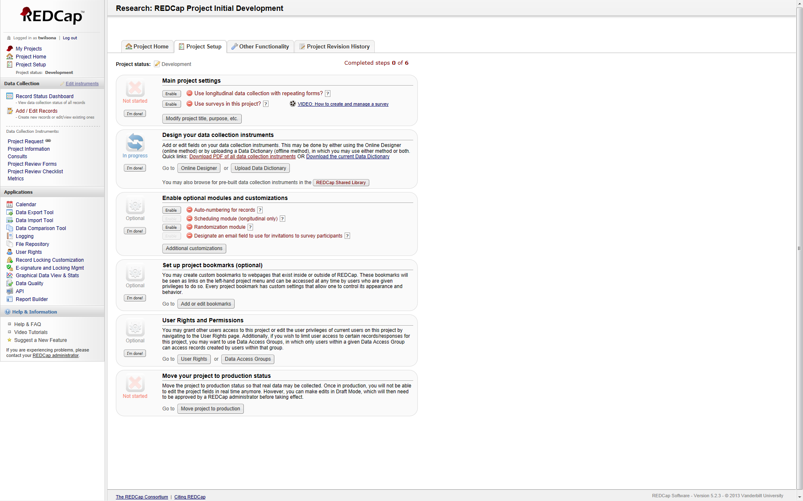

**Project Information Form**

This form stores information regarding a project and its current status.

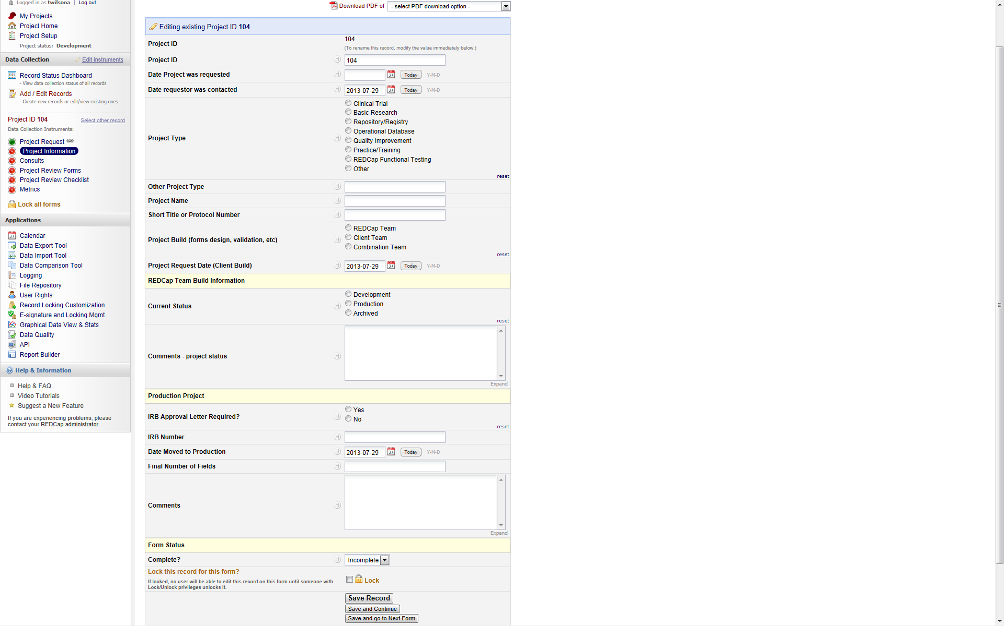

**Consults Form**

This form is used to store information regarding consultations about a project. Although, only one consultation is shown, branching logic is used to show multiple consultations when they are needed.

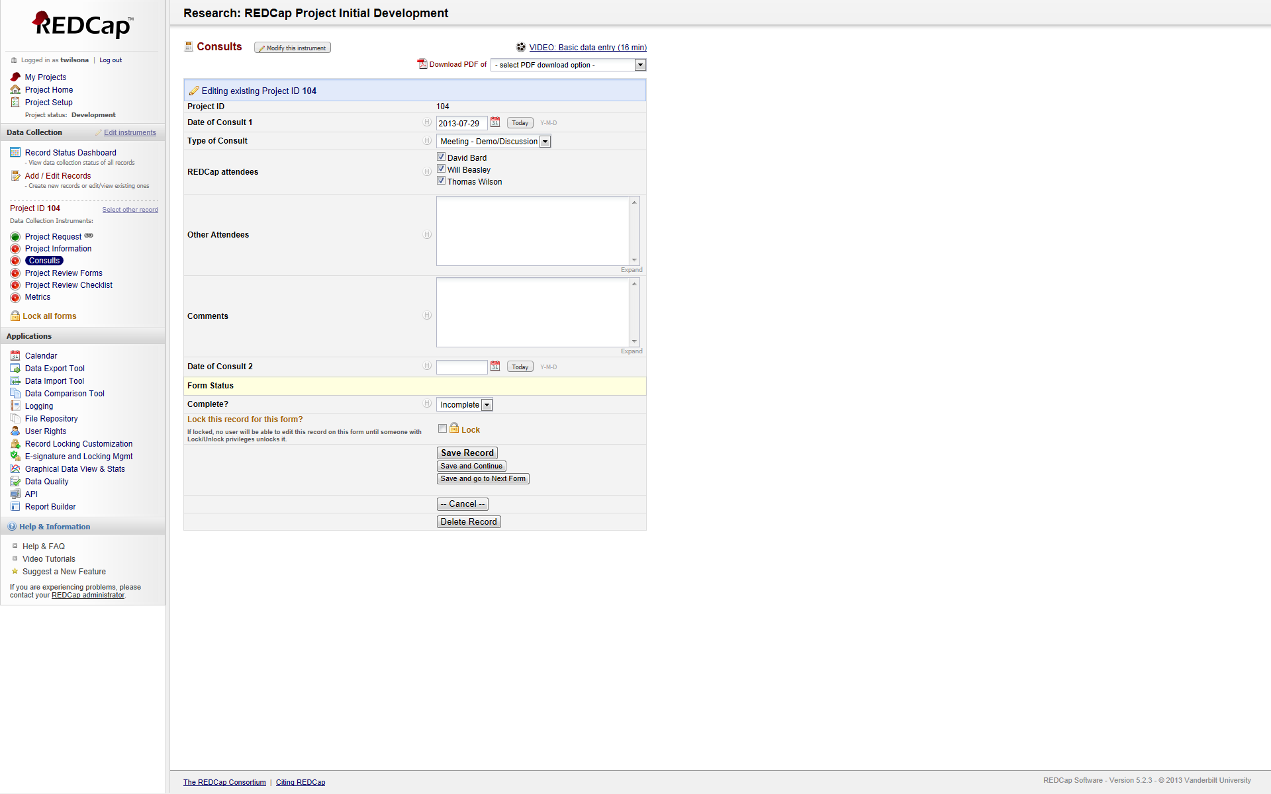

**Project Review Forms**

This form is used to record the review of the forms in a project. It includes checks for data validation, branching logic, form consistency, grammatical checks, and other. As with the consults form, only a few form comments are shown, but branching logic allows for multiple forms to be checked.

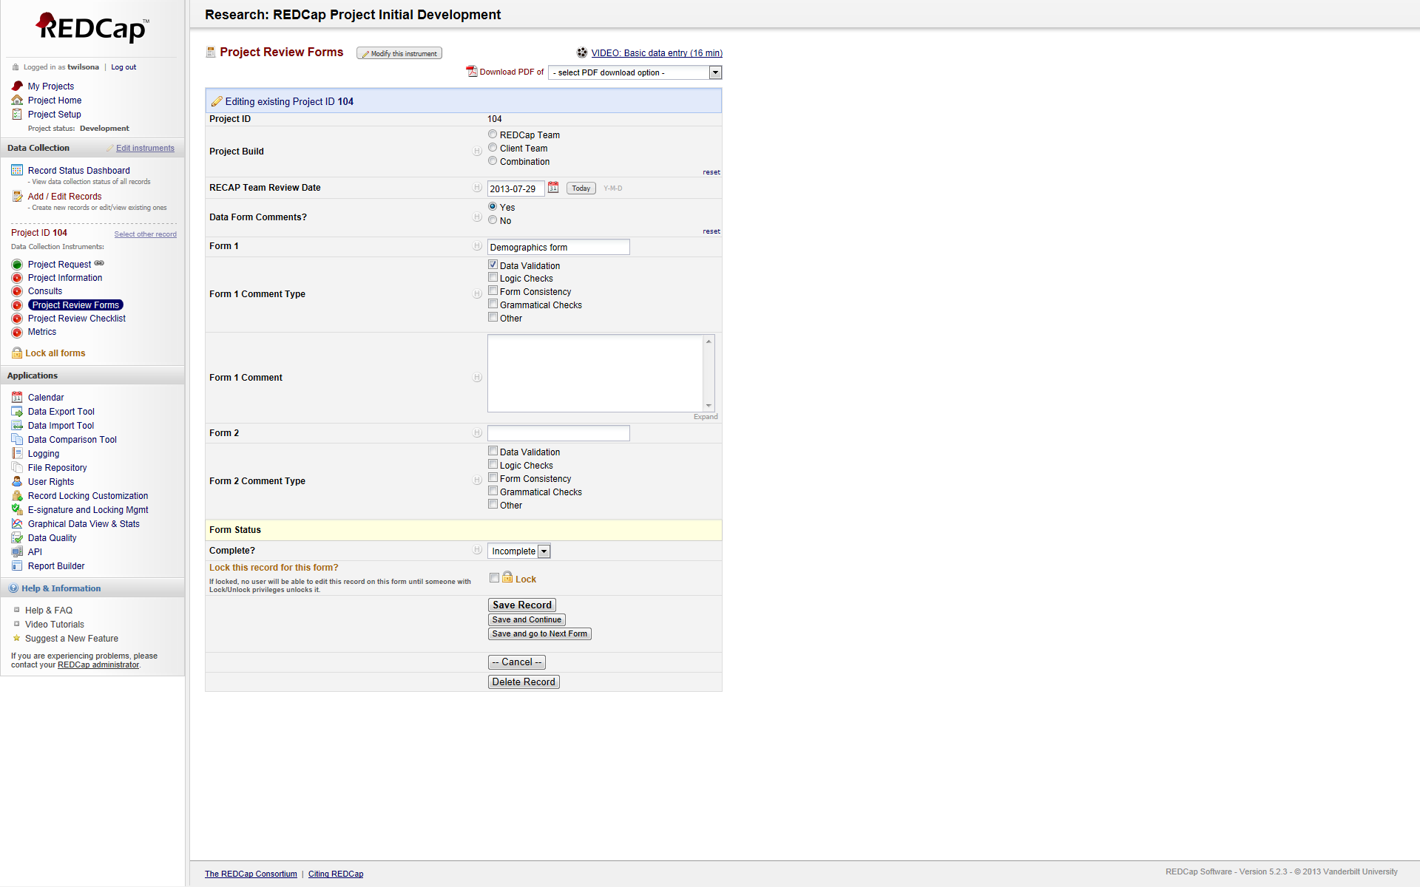

**Project Review Checklist**

This is a check list regarding the review of the project.

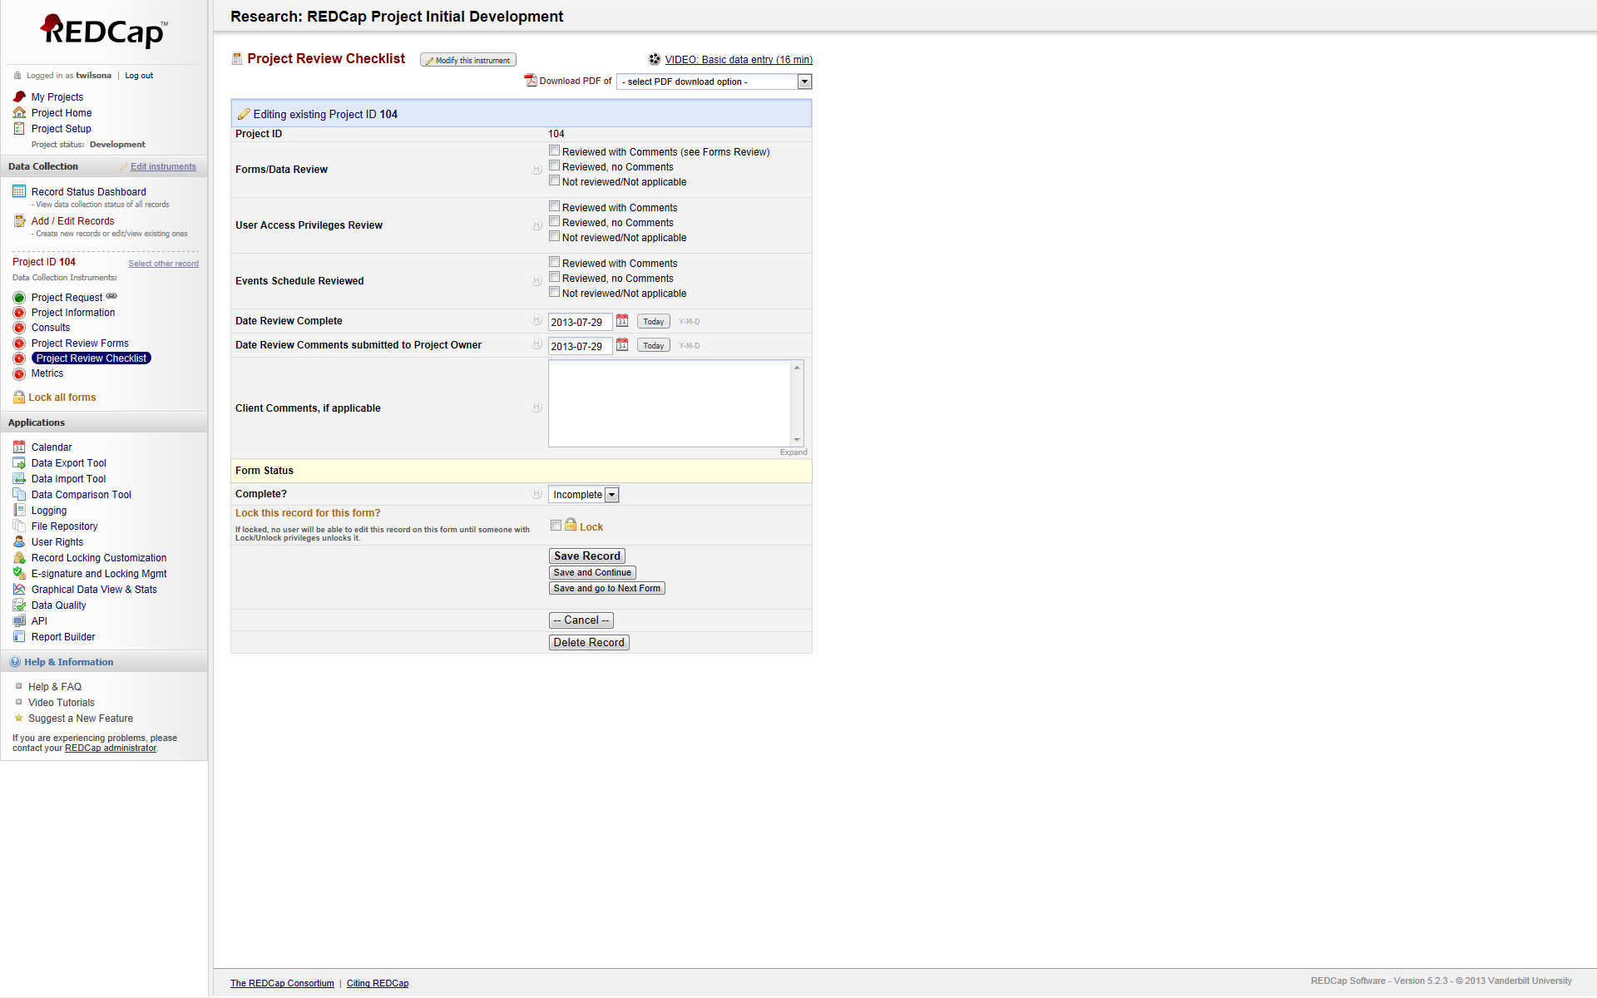

**Metrics**

The metrics form is designed to calculate the timeframes from the initial request to all phases of the project development. It calculates project configuration time and when a metric is decided on, it can calculate configuration cost.

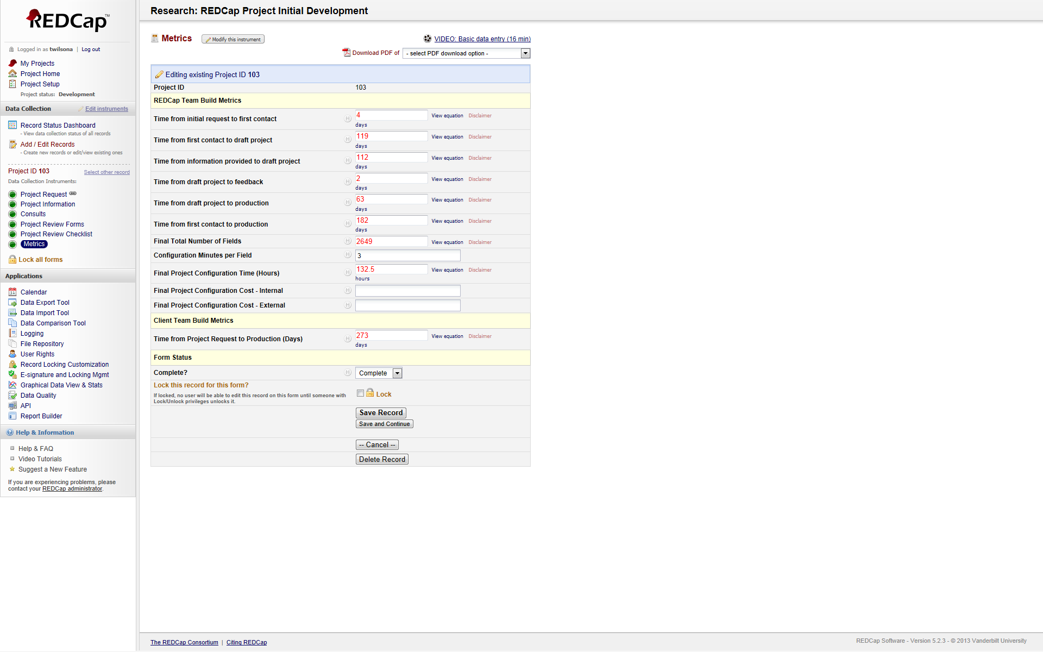

All of the projects mentioned here are linked to the initial request. The initial request stores all the information about the project owner. In any of the project forms, you have the capability to link back to the initial request for updates, modifications, etc.